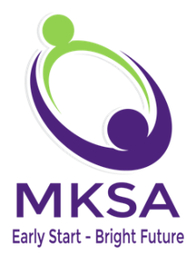

Acknowledgement of Corporate Compliance
Medicaid Mandated Training

Contents
- MKSA, LLC Corporate Compliance Plan
- Code of Conduct
- Documentation Requirements
- Enforcement of Compliance Standard
- False Claims Act and Whistleblower Provisions

  - I acknowledge that I have attended and/or read the Corporate Compliance training on this date. I have been provided with the opportunity to ask any questions that I may have.

  - I acknowledge that I have received and have read a copy of the Corporate Compliance Plan and the Code of Conduct. The manual is available on our website under provider forms.

  - I understand that I must comply with the Corporate Compliance Plan, the Code of Conduct, all laws, regulations, policies and procedures, and guidance provided.

  - I understand that I must report any instances of possible violations of the Corporate Compliance Plan, the Code of Conduct, laws, regulations and policies and procedures to a member of management or the Compliance Officer.

  - I understand that MKSA,LLC maintains a hotline for confidential or anonymous reporting of possible violations of the Corporate Compliance plan, the Code of Conduct, laws, regulations and policies and procedures.

  - I understand that my failure to comply with the Corporate Compliance Plan, the Code of Conduct, laws, regulations and policies and procedures or to report possible violations may result in disciplinary action, up to and including termination.

  - I acknowledge that the laws/rules of Medicaid Compliance and the False Claims and Whistleblower Provisions were reviewed at the time of my application with MKSA, LLC.

Print Name ___________________ Signature________________________

Discipline _____________________ Date____________________________

AV11.17

