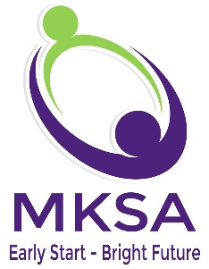
125 E. Bethpage Road, Suite 5 Plainview, NY 11803
516-731-5588 516-577-9049 fax
718-631-1110 718-631-1314 fax
www.mksallc.com

Professional Ethics Attestation

I, _________________________ hereby attest that on _________________

I read and reviewed Implementing Professional Boundaries, A Code of Ethics for Early Childhood Service Providers Working in the Home.

I agree to adhere to this policy.

I understand that corrective action may be imposed for a violation of the Code of Ethics.

___________________________ __________________________
Sign Name Print Name

________________
Date

This form will be retained in your file. A copy may be sent to the municipality you provide services under upon request.

A copy of the manual is available on our website under Provider Forms.

AV11.17

