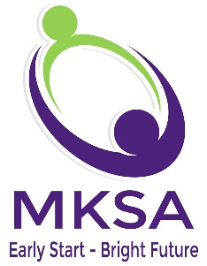
125 E. Bethpage Road, Suite 5 Plainview, NY 11803
516-731-5588 516-577-9049 fax
718-631-1110 718-631-1314 fax
www.mksallc.com

Date: ____________________

I _____________________________ have received the Mandatory Sexual Harassment Training provided by MKSALLC.
I understand that the full written Policy is also available for my review at any time on their website WWW.MKSALLC.COM.

Please Initial:
_________ I have viewed/read the training materials on Sexual Harassment in the workplace.
_________ I understand that I can report any incidences of Sexual harassment to a Supervisor/Manager at MKSA or directly to the Executive Directors Annie Vigliotti or JoAnn Scanlon
_________ I do not have any questions regarding this training at this time.
I have the following questions about the training and/or policy on Sexual Harassment:

_____________________________________________________________________________________________________
Please forward this form to Compliance@MKSALLC.com. An answer to your question will be sent to you via the email this form is received within 72 hours.

________________________________________ ____________________________________
Signature of Employee/Independent Contractor Discipline

